1.(1.sql) Find those pairs of Title IDs that have the same sold quantity. A pair should be listed only once, e.g., list (i, j), but not (j, i) as below.

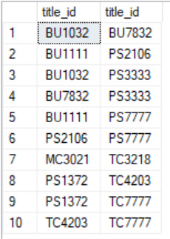

2.(2.sql) List store ID, title ID, order date, and quantity sold for all sales that occurred in the year 1994 from stores that either sold more than 20 copies of a single title or had a payment term of "Net 30" days. /

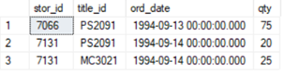

3.(3.sql) List all titles, and their sold number, including the sold total number of titles at the end. Use row_number() for the column [row].

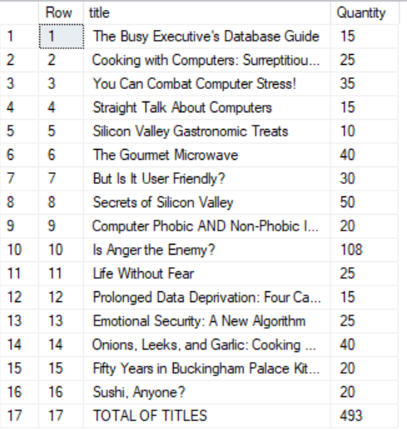

4.(4.sql) List all authors, and their number of titles, including the total number of titles at the end. Only count 1 for each title, even one title can be written by more than one author as below. Use row_number() for the column [row].

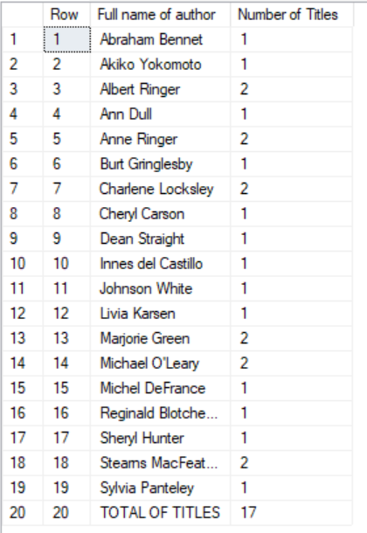

5.(5.sql) List titles that were published the most recently as below.

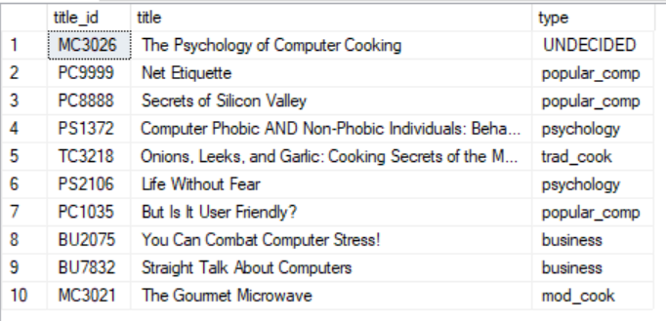

6.(6.sql) List employees that have the third character of the first name is ‘l’ as below With the given database instance, the result contains 2 records. /

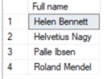

7.(7.sql) List employees hired by the publisher 'New Moon Books'' from 1990 to 1993 as below.

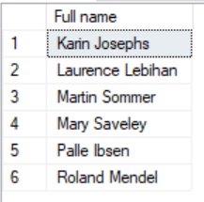

8.(8.sql) Find those pairs of publisher IDs that have the same number of employees. A pair should be listed only once, e.g., list (i, j), but not (j, i) as below.

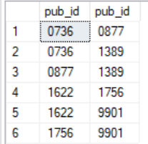

9.(9.sql) List authors that have the second character of the first name is ‘h’ as below.

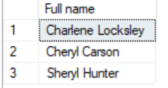

10.(10.sql) List total quantity, total amount of each title was sold by each store as below. /

